

**YEAR: 10**

**2017**

**SUBJECT: Science**

**TEST: Evolution**

**TIME: 30 minutes**

**QUESTIONS: 28 Multiple Choice (28 marks)**

**5 Short Answer (21 marks)**

**TOTAL MARKS: 49 marks**

**DO NOT WRITE ON OR MARK THIS PAPER**

**SECTION ONE—MULTIPLE CHOICE** (28 marks)

This section has **28** questions. Answer **all** questions on the separate Multiple-choice Answer Sheet provided.

_______________________________________________________________________________________

1. One of the major elements of natural selection is that all species have genetic
2. digression
3. melanism
4. stability
5. variation
6. A population of bacteria is treated with hand sanitizer. Because of genetic variation in the population, what is a possible outcome?
7. The population will grow quickly
8. All of the bacteria are already resistant
9. They will get better at obtaining a food source
10. Some may be resistant and survive
11. One of the biggest ways that a species evolves is because some organisms with some traits survive and reproduce better than others. This process is known as
    1. natural selection
    2. convergent evolution
    3. coevolution
    4. sexual selection
12. Genes for traits that help an organism be more successful reproductively can be expected to
13. cause it to evolve into a new species
14. become more common in the future
15. cause the extinction of the species
16. eventually be eliminated by natural selection
17. An adaptation is

a) any trait an organism possesses

b) how an organism evolves during its own lifetime

c) a gene an organism has

d) a trait that helps an organism survive in its environment

1. Genetic diversity is ***ultimately/mainly*** the result of
2. meiosis
3. viruses
4. mutations
5. reproduction
6. Which of the following does **NOT** increase genetic variation?
   1. Mutations
   2. Gene flow
   3. Mitosis
   4. Crossing over
7. Which of the following is **not** a principle of natural selection?
   1. Most species produce more offspring than will actually reproduce.
   2. Organisms compete for limited resources.
   3. Evolution will occur as an organism gets older and learns more.
   4. In every population, adaptations allows some organisms to survive and reproduce better than others.
8. Which of the following is **not** an example of evolution?
   1. Horses becoming taller and faster over millions of years.
   2. All species of tortoises in the Galapagos islands descending from a common ancestor.
   3. Human brains becoming larger over time.
   4. A caterpillar going through a change into a butterfly.
9. Individuals that are well adapted to their environment will survive and produce
   1. fewer mutations
   2. more offspring
   3. stronger genes
   4. better traits
10. Natural selection results in change over time by acting on traits that are
    1. heritable
    2. new
    3. mutated
    4. better
11. Organisms that live in similar environments, such as the ocean, often have similar adaptations. This is often due to
    1. convergent evolution
    2. coevolution
    3. gradualism
    4. sexual selection
12. Which pattern of evolution results in one species splitting into many over time?
    1. coevolution
    2. divergent evolution
    3. convergent evolution
    4. sexual selection
13. If scientists wanted to learn more about evolution by studying biochemistry, they would study all but one of these molecules. Which molecule would **NOT** offer much information about the history of life?
    1. DNA
    2. Proteins
    3. nucleic acids
    4. lipids (fats)
14. Scientists can explore whether two different animal species have evolved from a common ancestor, using evidence from all of the sources below **except**
    1. analysis of strands of DNA
    2. comparisons of bones and muscles
    3. comparison of the experiences of each organism
    4. studies of embryos during development

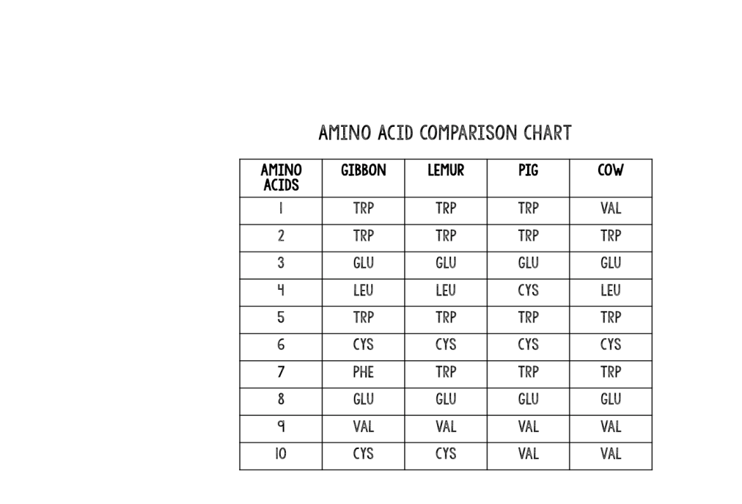

1. The table to the right shows the order of amino acids present in a protein from five different organisms. Based on this evidence, a researcher could conclude that the two closest relatives are
   1. Lemurs and gibbons.
   2. Lemurs and pigs.
   3. Cows and pigs.
   4. None of the above. Amino acids cannot be used to determine relatedness.
2. Two bodily structures, found in different species, have different internal bone structures but serve a ***similar purpose*** in each organism. This is the best description of
   1. homologous structures
   2. vestigial structures
   3. analogous structures
   4. natural selection

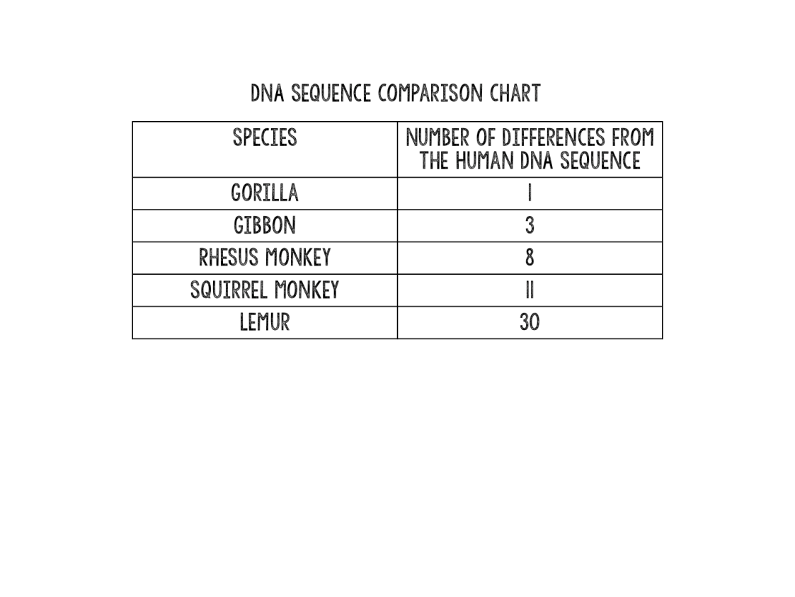

1. In the table to the right, the DNA found in five primate species was compared to the DNA found in humans. The number of sequence differences was recorded. Based on the data in this table, what inference could you make about these species compared to humans?
   1. Lemurs are most like humans.
   2. Gorillas are most like humans.
   3. None of the species are similar to humans.
   4. Only the lemur differs from humans in any way.
2. Ostriches have wings, but do not fly. Humans have an appendix with no apparent function. Whales contain bones for rear legs. Each of these are examples of
   1. homologous structures
   2. vestigial structures
   3. analogous structures
   4. natural selection
3. The best example of an analogous structure would be
   1. comparing a human arm and a whale arm.
   2. comparing a bat wing and a human arm.
   3. comparing a human eye and an insect eye.
   4. comparing a mosquito wing and a bumblebee wing.
4. Evidence of evolution from the field of paleontology examines
   1. sequences of DNA and protein.
   2. embryos of different species.
   3. the location of different species across the planet.
   4. fossils compared to living species.
5. Early during development, organisms as diverse as a human, a mouse, and a bat can appear indistinguishable. All of their embryos look nearly identical, suggesting that
   1. during development, humans go through stages of being a mouse and a bat.
   2. similar structures have developed because of convergent evolution.
   3. these very different species have a shared ancestry with all mammals.
   4. this is a coincidental resemblance between them.
6. Fossil evidence shows that structures considered vestigial in living organisms
   1. are not found in ancient organisms.
   2. have always been vestigial.
   3. were useful to their ancestors.
   4. do not fill gaps in the fossil record.
7. 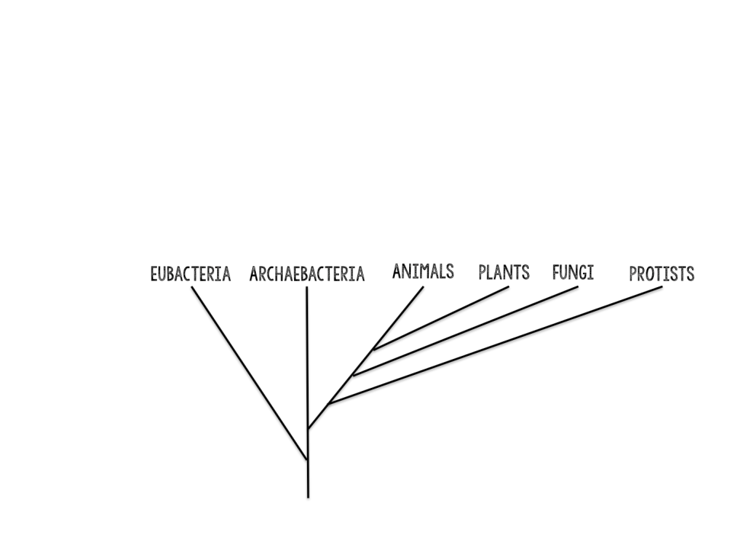According to the phylogenetic tree to the right,
   1. an ancestor of eubacteria gave rise to all life on earth.
   2. archaebacteria came from eubacteria.
   3. animals gave rise to plants and fungi.
   4. eubacteria and archaebacteria have no common ancestor.
8. Which scientist developed a classification system for organisms?
   1. Carolus Linnaeus
   2. Charles Darwin
   3. Jean-Baptiste Lamarck
   4. Georges L.L. de Buffon
9. According to binomial nomenclature, species are given two names based on their
   1. Kingdom, species
   2. Genus, species
   3. Class, phylum
   4. Kingdom, phylum
10. Which one of these is most closely related to the organism on the left?

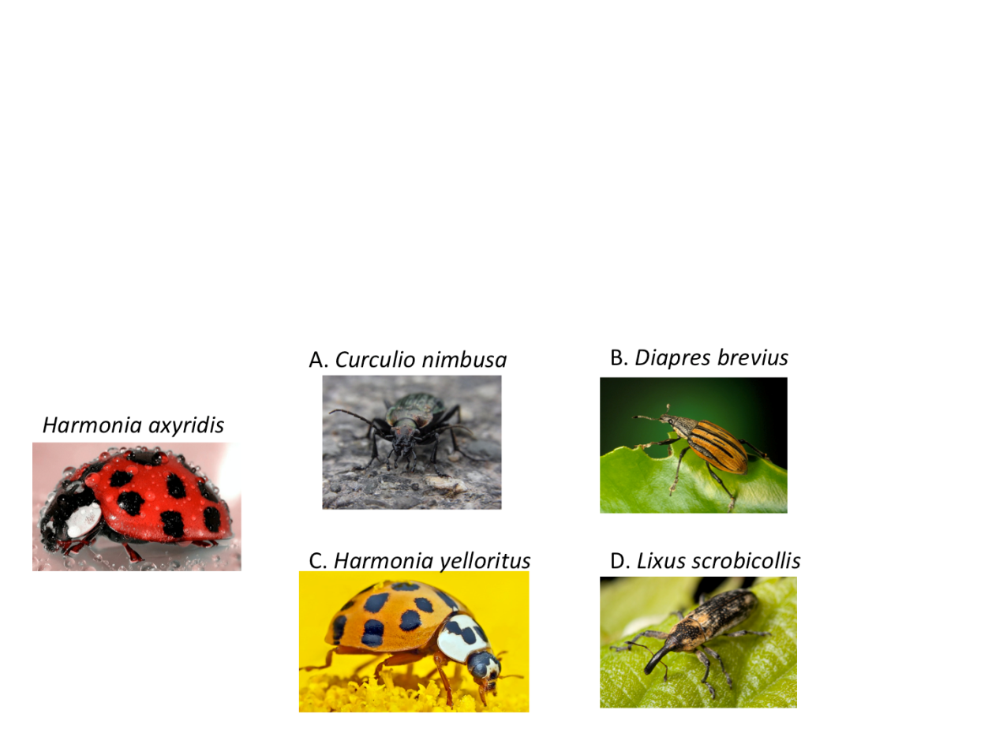

1. Which of the following sequences shows the correct hierarchy of classification, going from broadest to most specific?
   1. Kingdom, Domain, Phylum, Order, Class, Family, Genus, Species
   2. Domain, Kingdom, Phylum, Class, Order, Family, Genus, Species
   3. Genus, Species, Kingdom, Phylum, Order, Class, Family, Domain
   4. Domain, Phylum, Kingdom, Genus, Species, Family, Order, Class

**END OF MULTIPLE CHOICE SECTION**



**SEMESTER TWO 2017**

**Evolution Test:**

**ANSWER BOOKLET**

**NAME:**

**FORM:** **DATE:**

Multiple Choice Short Answer Total

**/28**

**/49**

**/21**

**SECTION ONE:** Multiple choice answers

Cross (X) through the correct answer.

|  |  |  |  |  |
| --- | --- | --- | --- | --- |
| **1** | a | b | c | d |
| **2** | a | b | c | d |
| **3** | a | b | c | d |
| **4** | a | b | c | d |
| **5** | a | b | c | d |
| **6** | a | b | c | d |
| **7** | a | b | c | d |
| **8** | a | b | c | d |
| **9** | a | b | c | d |
| **10** | a | b | c | d |
| **11** | a | b | c | d |
| **12** | a | b | c | d |
| **13** | a | b | c | d |
| **14** | a | b | c | d |

|  |  |  |  |  |
| --- | --- | --- | --- | --- |
| **15** | a | b | c | d |
| **16** | a | b | c | d |
| **17** | a | b | c | d |
| **18** | a | b | c | d |
| **19** | a | b | c | d |
| **20** | a | b | c | d |
| **21** | a | b | c | d |
| **22** | a | b | c | d |
| **23** | a | b | c | d |
| **24** | a | b | c | d |
| **25** | a | b | c | d |
| **26** | a | b | c | d |
| **27** | a | b | c | d |
| **28** | a | b | c | d |

**SECTION TWO: Short Answer (21 marks)**

Answer the questions in the spaces provided.

_______________________________________________________________________________________

1. A forest has many trees and bushes that produce nuts. This is a major food source for many species, include a particular bird. Birds of this species have a variety in beak shapes ranging from long and pointy to short and hard. The birds with short and hard beaks are able to eat the nuts better than the birds with long and pointy beaks.

What do you expect to happen to this population of birds over time, in terms of what you know about evolution? Address all four principles of natural selection in your explanation. (5 marks)

1. Match the following vocabulary terms with the correct descriptions. (6 marks)

|  |  |
| --- | --- |
| 1. Gradualism | A. Multiple species evolving from a common ancestor. |
| 2. Speciation | B. Burst of evolutionary change followed by periods of stability. |
| 3. Punctuated Equilibrium | C. Formation of a new species from a pre-existing species. |
| 4. Divergent Evolution | D. Slow evolutionary changes over a long period of time. |
| 5. Convergent Evolution | E. When two organisms evolve in response to the other. |
| 6. Coevolution | F. When unrelated species evolve similar characteristics because they live in similar environments. |

1. Male peafowl, called peacocks, have long, colourful tail feathers. Among peacocks there is variation in the size, brightness, and pattern of the tail. Scientists observed the mating success of two groups of peacocks. The graph below shows the scientists’ data.

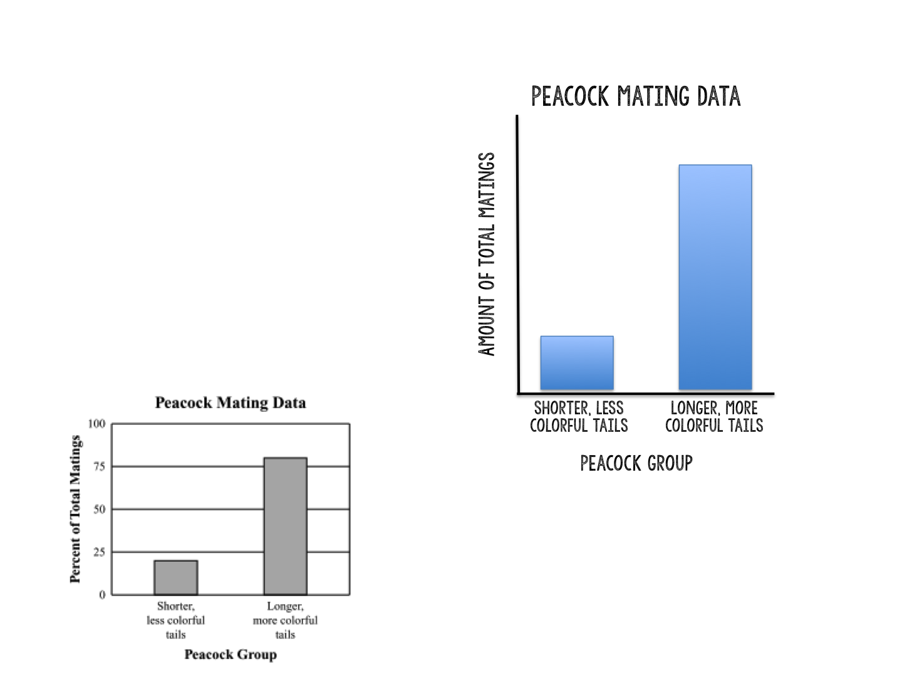

* 1. Explain what the graph shows about the advantage of longer, more colourful tails for peacocks. (1 mark)

* 1. Identify **one** disadvantage that longer, more colourful tails may have for peacocks. (1 mark)

* 1. Explain how you think the longer, more colourful tails evolved in peacocks despite causing disadvantages for the males, based on what we’ve learned about evolution. (2 marks)

1. List **two** of the five fields of science discussed in class and why/how they provide evidence for evolution. (2 marks)

4. Use the phylogenetic tree below to answer the following questions: (4 marks)

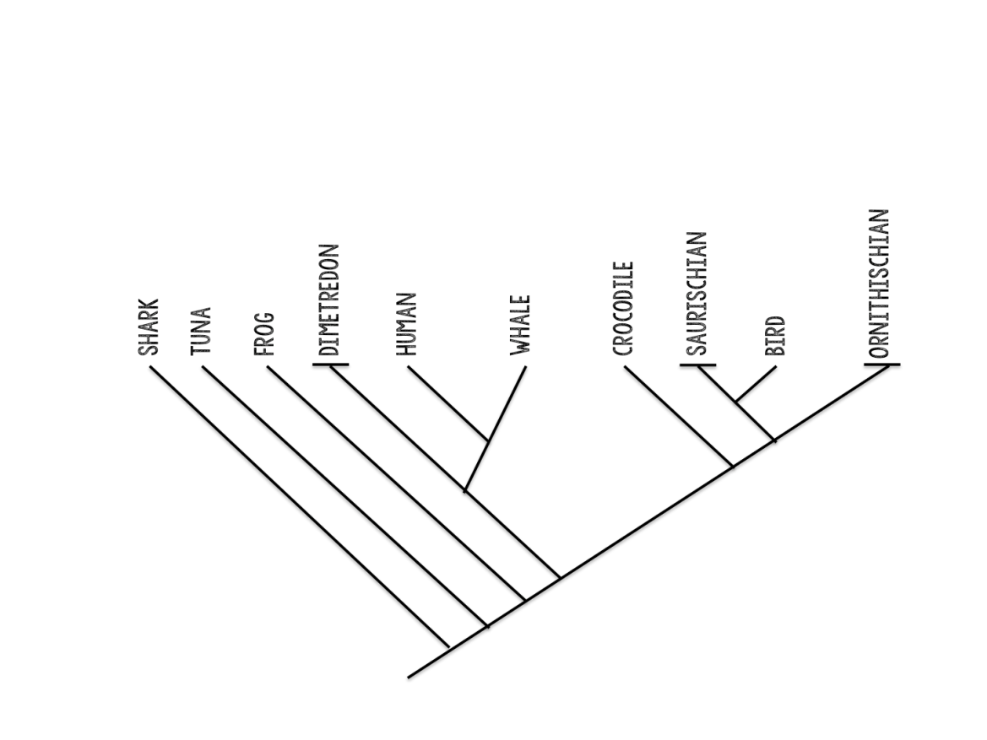

* 1. Which organism diverged first?
  2. Who is most closely related to the human?
  3. What do all of these organisms share?
  4. Is the crocodile more similar in features to the Dimetrodon or the bird?